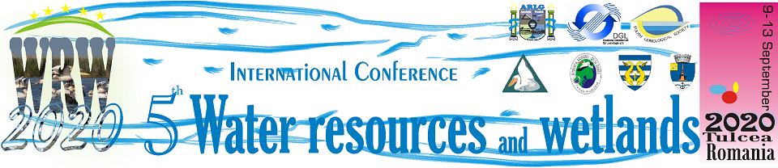
Tulcea, Romania, September 8–12, 2021

Official Conference website is:
http://www.limnology.ro/wrw2020/abstract.html
Please complete this form and return by E-mail latest until
June 28, 2021
• e-mail: wrw_conference@limnology.ro
Registration
Delegate (if it is necessary add more delegates) | Mr. | Ms.
 |  |  | PhD student | Dr. | Prof. | Other
Full Familiy name
Full First name
Company/University/Institution
Address
City
Postal Code
Country
Phone
Fax
E-mail

Member of
 | Yes | No
Romanian Limnogeographical Association
German Limnological Society
Polish Limnological Society
Danube Delta National Institute for Research and Development (DDNIRD) Tulcea

Accompanying person
Mr | Ms | Full name

Type of presentation:
Oral | Poster

Type of participation:

In-person (face to face) | Virtual
Themes and Topics http://www.limnology.ro/wrw2020/topic.html
Thematic sessions
TS1. Microplastic in water and environment
TS2. Impact of Anthropogenic activity in Mediterranean watersheds
TS3. Connectivity of Inland Waters (Habitat Structure, Fragmentation and Biodiversity)
TS4. Remote sensing and GIS - support for monitoring of inland waters
TS5. Aquatic toxicology & Aquatic microbiology

Regular sessions
RS1. Rivers and lakes ecosystem ecology
RS2. Climate changing and water resources
RS3. Coastal environment
RS4. Deltas and wetlands
RS5. Water policies

Intend to
Only Participate with oral or poster presentation.
Abstract will be available on the book of abstracts
Participate and publish my article /full paper
Only publish my article / full paper

Field trip Danube Delta |  | The Organizers have arranged for a shuttle bus system to be operating upon arrival and departure of WRW2021 participants.  Intend to use our bus transfer system?  (Bucharest-Tulcea-Bucharest –  It is free of charges for participants according with the shuttle bus program (program will be available later).  Individual transfer is not accepted
Yes | No | Yes | No

Abstract submission (Abstract is a part of registration form)
ABSTRACT MODEL:
TITLE
First name LAST NAME¹, First name LAST NAME² (all authors)
¹Affiliation, ²Affiliation (including email)

Abstract
Text text text text text text text text text text text text text text text text
(400 – 500 words in English, No graphs, tables, and references be included in the Abstract)

Keywords: word, word, word, word, word, word (maximum 6)

Photography/Video Agreement: In submitting your conference registration and attending the 2020 Water resources and wetlands Conference you understand that you may be included in photographs and video taken during the conference, and you agree and understand that these images may be used in print, video and the Internet for promotional purposes for the Water resources and wetlands Conference.
Related to the Regulation (EU) 2016/679 on the protection of natural persons with regard to the processing of personal data, by submitting your registration to the conference, you agree that your personal data be included in the database of the WRW2020 conference and some of them will be public (e.g. e-mails, affiliation, institutional address).

