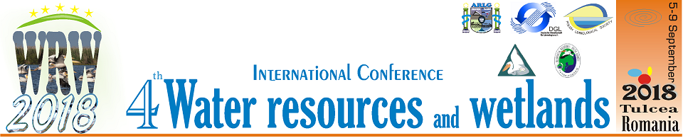Tulcea, Romania, September 5–9, 2018

Official Conference website is:
http://www.limnology.ro/wrw2018/abstract.html
Please complete this form and return by E-mail latest until June 25, 2018.
• e-mail: wrw_conference@limnology.ro

Registration
Delegate | Mr. | Ms.
 |  |  | PhD student | Dr. | Prof. | Other
Full Familiy name
Full First name
Company/University/Institution
Address
City
Postal Code
Country
Phone
Fax
E-mail

Member of
 | Yes | No
Romanian Limnogeographical Association
German Limnological Society
Polish Limnological Society
Danube Delta National Institute for Research and Development (DDNIRD) Tulcea

Accompanying person
Mr | Ms | Full name

Type of presentation:
Oral | Poster

Themes and Topics
A. Rivers and lakes ecosystem ecology
B. Climate changing and water resources
C. Coastal environment
D. Deltas and wetlands
E. Water policies

Intend to
Only Participate with oral or poster presentation.
Abstract will be available on the book of abstracts
Participate and publish my article /full paper | Not available
Only publish my article / full paper | Not available

Abstract submission (Abstract is a part of registration form)
No graphs, tables, and references be included in the Abstract.
Title
Author(s)
(full name – for all authors)
University/Company/
Institution for all authors
E-mail contact
Abstract (max. 400 words)
Keywords (max. 6)

Field trip Danube Delta |  | The Organizers have arranged for a shuttle bus system to be operating upon arrival and departure of WRW2018 participants.  Intend to use our bus transfer system?  (Bucharest-Tulcea-Bucharest –  It is free of charges for participants according with the shuttle bus program (program will be available later).  Individual transfer is not accepted
Yes | No | Yes | No

Photography/Video Agreement: In submitting your conference registration and attending the 2018 Water resources and wetlands Conference you understand that you may be included in photographs and video taken during the conference, and you agree and understand that these images may be used in print, video and the Internet for promotional purposes for the Water resources and wetlands Conference.

