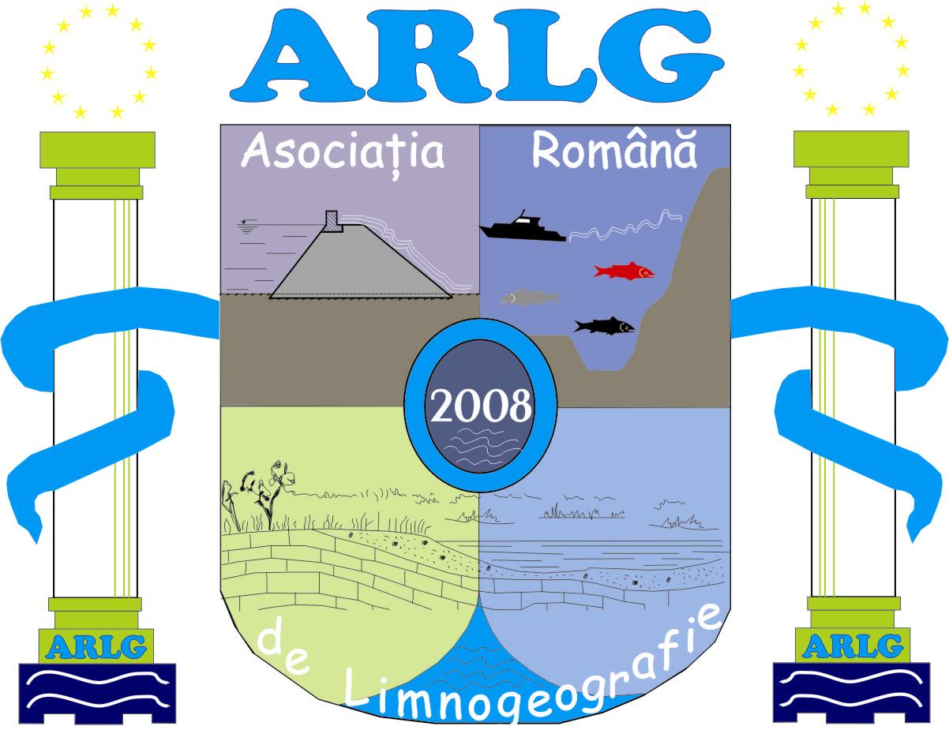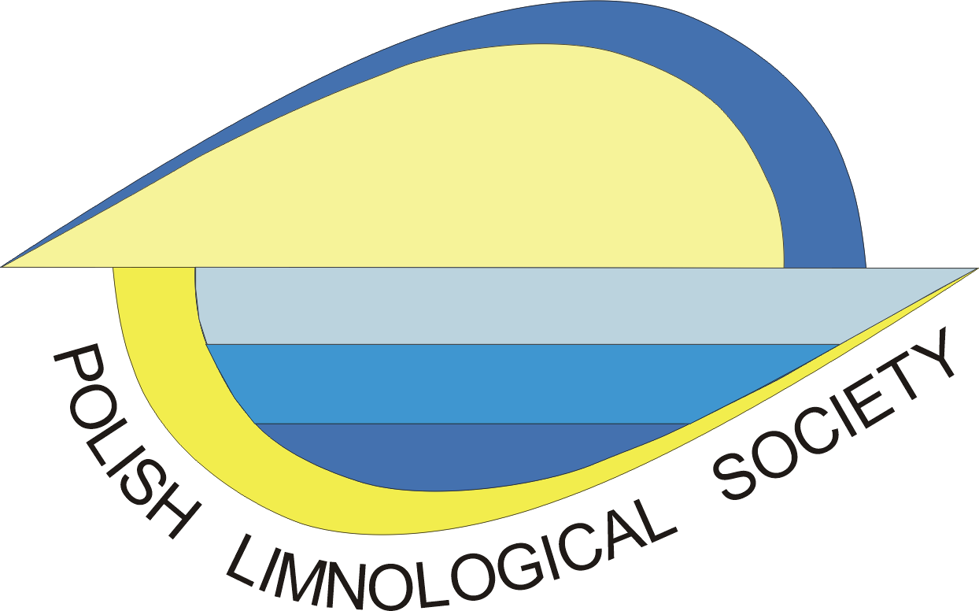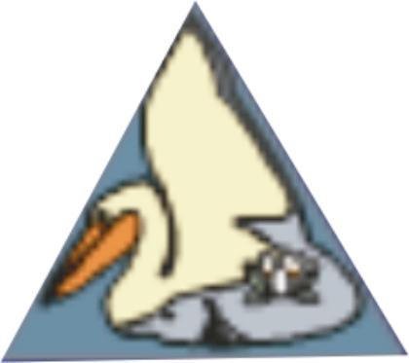
Romanian Limnogeographical German Limnological Polish Limnological Danube Delta National
Association Society Society Institute Tulcea

3rd International Conference
Water resources and wetlands
Tulcea, Romania, September 8–10, 2016
Official Conference website is:
http://www.limnology.ro/wrw2016.html

Please complete this form and return by E-mail latest until July 15, 2016.

• e-mail: water2016@limnology.ro

Registration
Delegate | Mr. | Ms. | Dr. | Prof. | Other
Full Familiy name
Full First name
Company/University/Institution
Address
City
Postal Code
Country
Phone
Fax
E-mail

Member of
 | Yes | No
Romanian Limnogeographical Association
German Limnological Society
Polish Limnological Society
Danube Delta National Institute for Research and Development (DDNIRD) Tulcea

Accompanying person

Mr___ Mrs___ Last name____________________________ First name _____________________________

Type of presentation:
Oral | Poster

Themes and Topics
A. Rivers and lakes ecosystem ecology
B. Climate changing and water resources
C. Coastal environment
D. Deltas and wetlands
E. Water policies

Intend to
Only Participate
Participate and publish my article | Not available
Only publish my article | Not available

Abstract submission (Abstract is a part of registration form)
No graphs, tables, and references be included in the Abstract.
Title
Author(s)
University/Company/Institution
E-mail contact
Abstract (max. 400 words)
Keywords (max. 6)

Field trip Danube Delta: Yes  No 

